**SALARYBOOK**

***A Report submitted***

***in partial fulfilment for the Degree of***

**B.E. in**

**Computer Science & Engineering**

***by***

**Mojidra Yagnik Prakash Bhai**

pursued in

**Department of Computer Science & Engineering**

**Faculty of Engineering & Technology**

To



**THE MAHARAJA SAYAJIRAO UNIVERSITY OF BARODA**

**VADODARA, GUJARAT**

**NOVEMBER, 2022**

# CERTIFICATE

This is to certify that the project report entitled **Salary book** submitted by **Mojidra Yagnik Prakash Bhai** to the Department of Computer Science & Engineering, Faculty of Technology & Engineering, in partial fulfilment for the award of the degree of **B.E. in (Computer Science & Engineering)** is a *bona fide* record of project work carried out by him under my supervision. The contents of this report, in full or in parts, have not been submitted to any other Institution or University for the award of any degree or diploma.

|  |  |
| --- | --- |
| **Mr. Sunny Kamra**  Supervisor  Department of Computer Science  & Engineering |  |

DECLARATION

I declare that this project report titled **Salary Book** submitted in partial fulfilment of the degree of **B.E. in (Computer science & Engineering)** is a record of original work carried out by me under the supervision of **Mr. Sunny Kamra**, and has not formed the basis for the award of any other degree or diploma, in this or any other Institution or University. In keeping with the ethical practice in reporting scientific information, due acknowledgements have been made wherever the findings of others have been cited.

**Mojidra Yagnik Prakash Bhai**

**2019033800126574**

# 

# ACKNOWLEDGMENTS

I would like to hereby take this opportunity to thank all the people who have been involved generously in helping me and assisting me during the entire period of my Minor Project.

Firstly, I am grateful to the Computer Science and Engineering department at The Maharaja Sayajirao University of Baroda for granting me the opportunity for the Minor Project.

We devote our success in this effort to our project guide Mr Sunny Kamra for giving us the opportunity to undertake the project and providing constant supervision, valuable knowledge and crucial feedback that influenced us and provided opportunity to undertake the project work in the esteemed concern.

Last, but not the least, we would like to extend our profound thanks to all our esteemed colleagues and friends at college level who

helped us in the specific areas of this project.

Mojidra Yagnik Prakash Bhai

2019033800126574

# 

# ABSTRACT

Salary and Attendance management system will not responsible to calculate salary of employees working within business but it will also able to perform other management activities which is required to perform their accounting operations for a particular business such as maintain attendance of working employees, etc.

Accountant do not have to perform much activities in order to maintain accounting operations with few steps such as automatic Calculate withdraw amount of salary based of Employee attendance.

This system will also provide its admin to get details on list of employees with all business operations.

As each processing work will used different file system and file system will act as central database to maintain data integrity and reduce redundancy.

Thus, system has been embedded with two facilities under one common platform that means salary and attendance management system will able to acts as employee information system and salary management system.

**TABLE OF CONTENTS**

CERTIFICATE ii

DECLARATION iii

ACKNOWLEDGMENTS iv

ABSTRACT v

1. INTRODUCTION 5

1.1 Problem Statement 5

1.2 Objective 5

2. DESIGN 6

2.1 Technologies 6

2.1.1 Frontend technologies and libraries 6

2.1.2 Backend technologies, libraries and database 6

2.1.3 Other technologies and tools 6

2.2 Functionality 7

2.2.1 Home Page 7

2.2.2 Aboutus Page 7

2.2.3 Term and conditions Page 7

2.2.4 Privacy Page 7

2.2.5 Login/Signup Page 7

2.2.6 Otp Verify page 7

2.2.7 Dashboard page 7

2.2.8 Profile Page 7

2.2.9 Business Page 8

2.2.10 Employees Page 8

2.2.11 Employees Attendence Page 8

2.2.12 Employees Salary Page 8

3. IMPLEMENTATION 9

3.1 Frontend (User Interface) 9

3.1.1 Home Page 10

3.1.2 About us Page 11

3.1.3 Terms and Conditions Page 12

3.1.4 Privacy Policy Page 13

3.1.5 Login Page 14

3.1.6 SignUp Page 15

3.1.7 Otp verify Page 16

3.1.8 DashBoard Page 17

3.1.9 Profile Page 18

3.1.10 Business details Page 19

3.1.11 Employees details Page 20

3.1.12 Employees Attendance Page 21

3.1.13 Employees Salary Page 22

3.2 Backend 23

3.2.1 Database MongoDB 23

3.2.2 Django 25

REFERENCES 26

**LIST OF FIGURES**

Fig3.1 Home page 10

Fig3.2 About Us page 11

Fig3.3 Term and Conditions page 12

Fig3.4 Privacy page 13

Fig3.5 Login page 14

Fig3.6 Signup page 15

Fig3.7 Otp Verify page 16

Fig3.8 Dashboard page 17

Fig3.9 Profile page 18

Fig3.10 Business Details page 19

Fig3.11 Employees Details page 20

Fig3.12 Employees Attandance Details page 21

Fig3.13 Employees Salary Details page 22

**LIST OF TABLES**

Table3.1 User Details 23

Table3.2 Business Details 24

Table3.3 Employees Details 24

Table3.4 Employees Attendance Details 25

# 

# CHAPTER 1

# INTRODUCTION

## Problem Statement

* To keep and manipulate the details of all employees in business.
* To keep record of employee’s details and employee’s attendance details.
* To keep and manipulate the details of all business.
* To keep record of business’s details.
* To help small business to grow their business using this system.
* This system is provided free to use for business owner.
* First we apply this system to grow’s our Uncle’s Business.

## 1.2 Objective

The objective of the project is to make a website that is easy to use, convenient to different types of Business owner. To Help small business to grow theirs own’s hand. Feel free to contact us for this system inquiry.

# 

# CHAPTER 2

# DESIGN

This chapter discusses about functionality of SALARYBOOK website and which technologies, libraries and database used to develop SALARYBOOK website.

## 2.1 Technologies

We have used some latest technologies/frameworks that makes our complex coding part easy to develop our website.

### 2.1.1 Frontend technologies and libraries

* JavaScript
* HTML
* Bootstrap5
* CSS3
* Free Icons

### 2.1.2 Backend technologies, libraries, and database

* Django
* Smtp Mail sender
* MongoDB Database with community version

### 2.1.3 Other technologies and tools

* VS Code
* GitHub
* Google Mail System

## 2.2 Functionality

The main features of the web application are:

### 2.2.1 Home Page

First user shows our home page.

### 2.2.2 About Page

Then user shows our About Us page.

### 2.2.3 Term and conditions Page

Then user shows our term and conditions page.

### 2.2.4 Privacy page

Then user shows our privacy page.

### 2.2.5 Login/Signup Page.

For access of our dashboard page first user need to login and signup our page.

### 2.2.6 Otp Verify Page.

For access of our dashboard page first user need to verify the otp page.

### 2.2.7 Dashboard Page.

After login or Signup user will redirect to Dashboard page.

### 2.2.8 Profile section.

In profile section user shows their Profile.

### 2.2.9 Business Details section.

In this section user manage their business details.

### 2.2.10 Employees Details section.

In this section business owner manage their employees’ details.

### 2.2.11 Employees Attendance Details section.

In this section business owner manage their employees’ attendance details.

### 2.2.12 Employees Salary Details section.

In this section business owner views, their employees’ salary details.

# 

# CHAPTER 3

# **IMPLEMENTATION**

## 3.1 Frontend (User Interface)

For frontend of our website, we have used Html, CSS, JavaScript, bootstrap.

Entire frontend is divided into multiple pages like home page, about page, terms and conditions page, privacy policy page, profile page, dashboard page, business details page, Employees details page, Employees attendance page, Employees salary page etc. If any new user comes he/she can sign up website services/functionality. Without credentials user try to access those pages then user will be redirected to home page. If user has credentials, then user can access every page of website.

Home page of website is shown below. From Home page user can redirect to login page if user has credentials otherwise, can redirect to signup page for registering to website.

### 3.1.1 Home Page

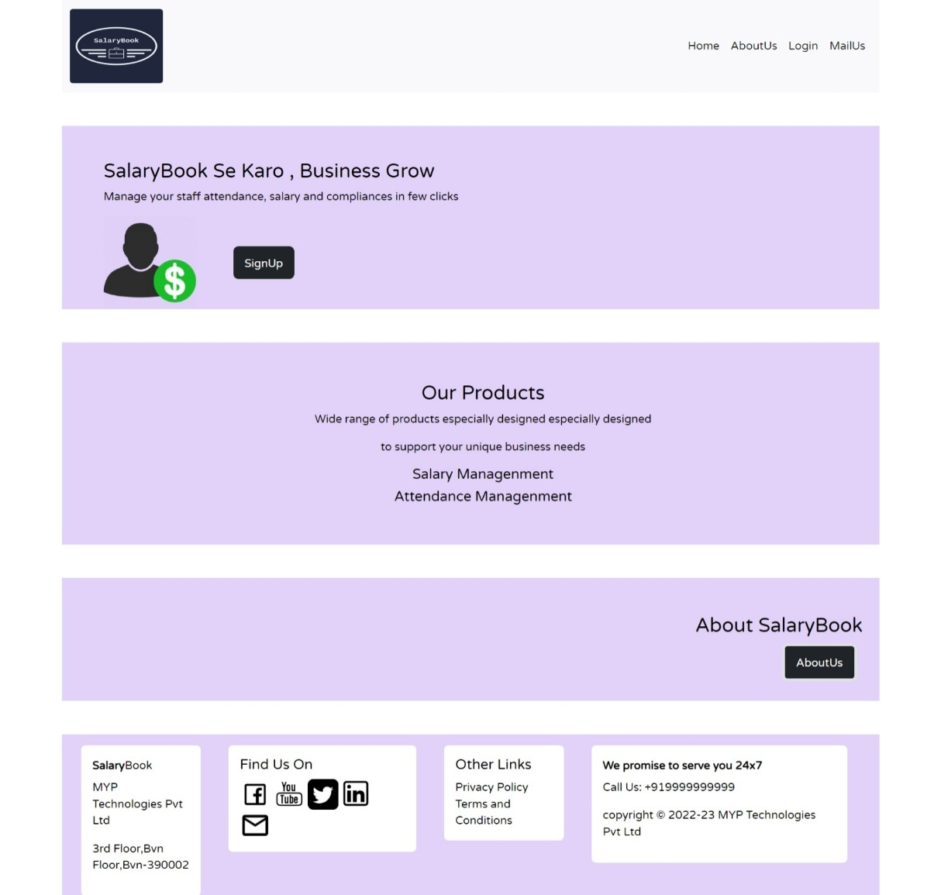

Fig 3.1 Home page

This is Home Page of Salary Book . This is Basic Home Page of Salary Book. And There is many link to Redirect Another Page.

### 3.1.2 About Us Page

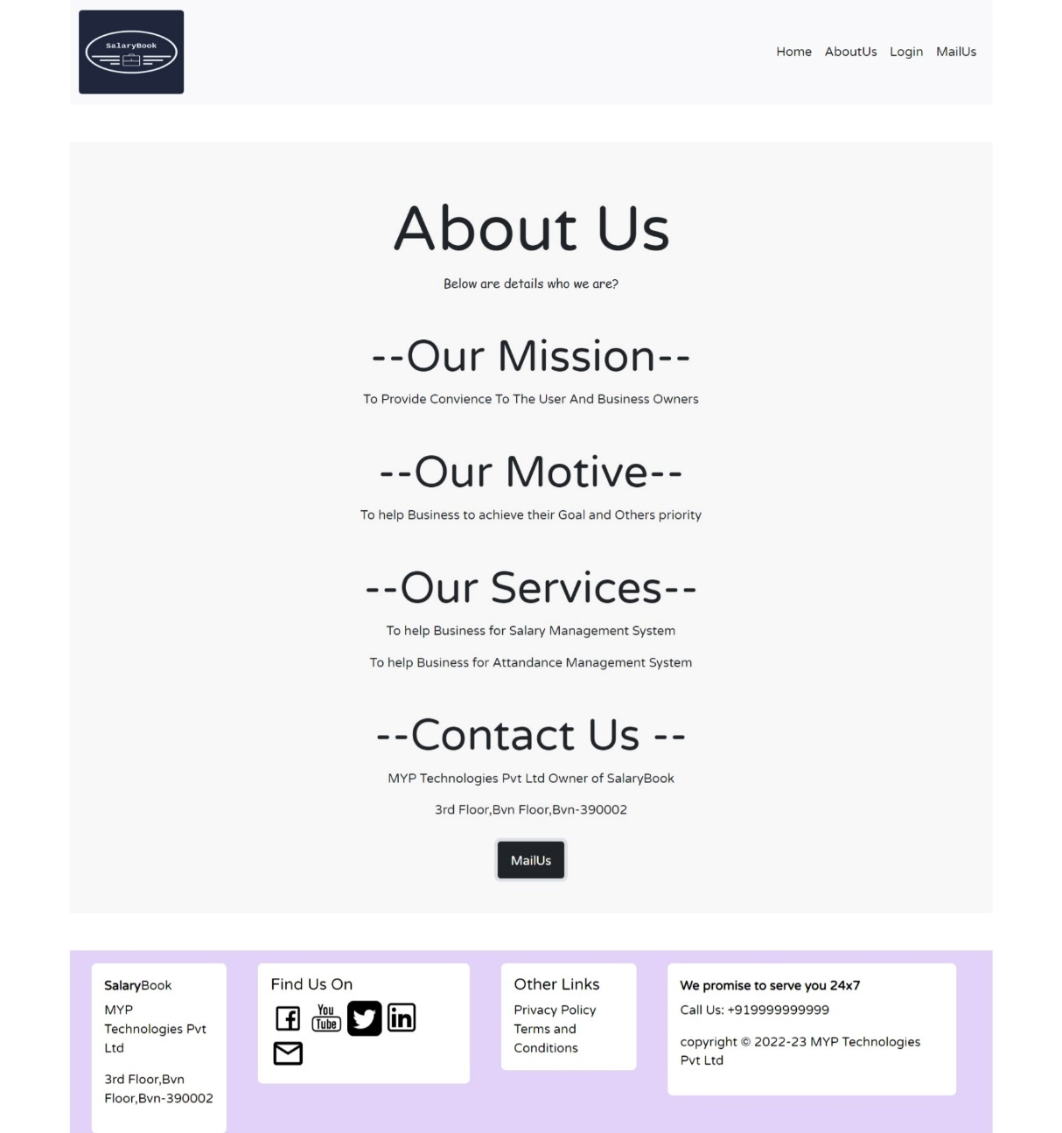

Fig 3.2 About Us Page

This is about page of Salary book .That page Shows about our mission, our Motive, our Services etc.

### 3.1.3 Terms and Conditions Page

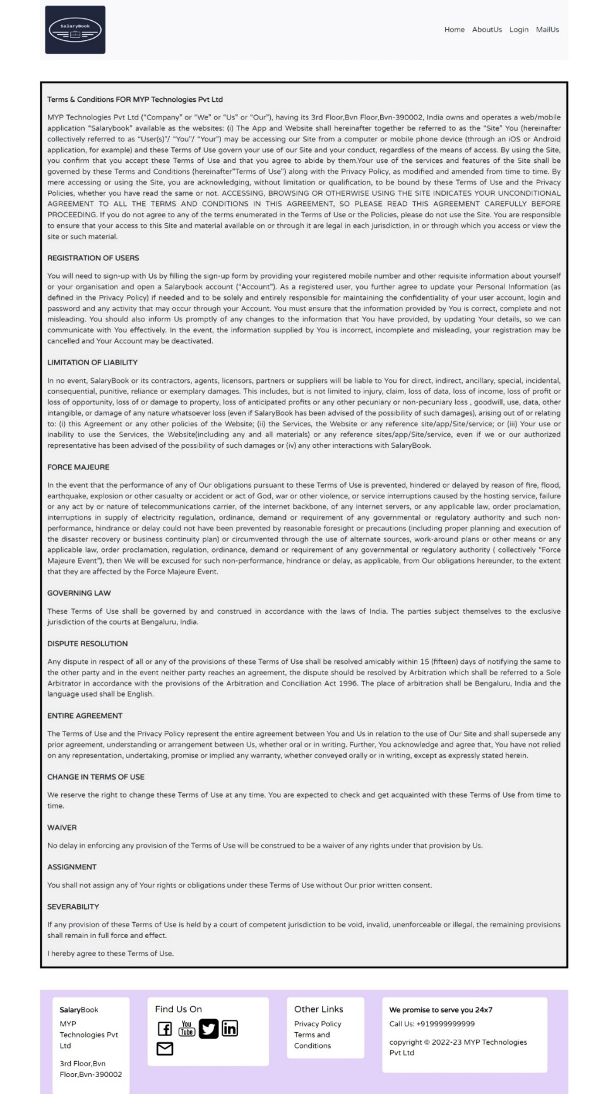

Fig 3.3 Term and Conditions Page

This is Term and Conditions Page about Salary Book. There is conditions about to use Salary Book web App.

### 3.1.4 Privacy Policy Page

Fig 3.4 Privacy Policy Page

That page shows about Privacy Policy Of Salary book.

### 3.1.5 Login Page

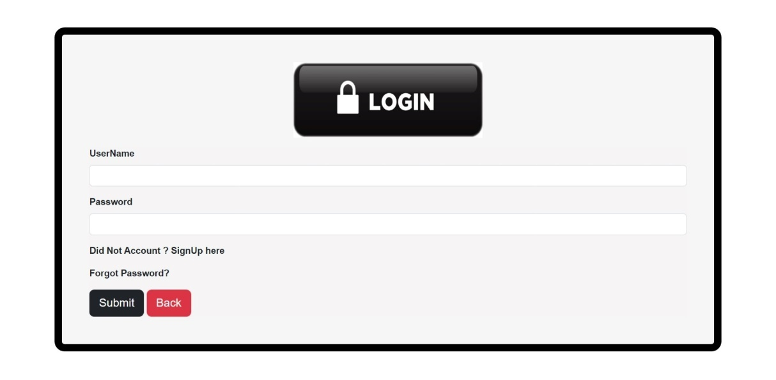

Fig 3.5 Login Page

That page is login page of Salary Book web applications. There is username and password field for using Salary Book Web Applications. If user has no username and password then user first register the Salary Book Web Applications .If user forgot their password then user will be able to change their password using forgot password facility with mail system.

### 3.1.6 Signup Page

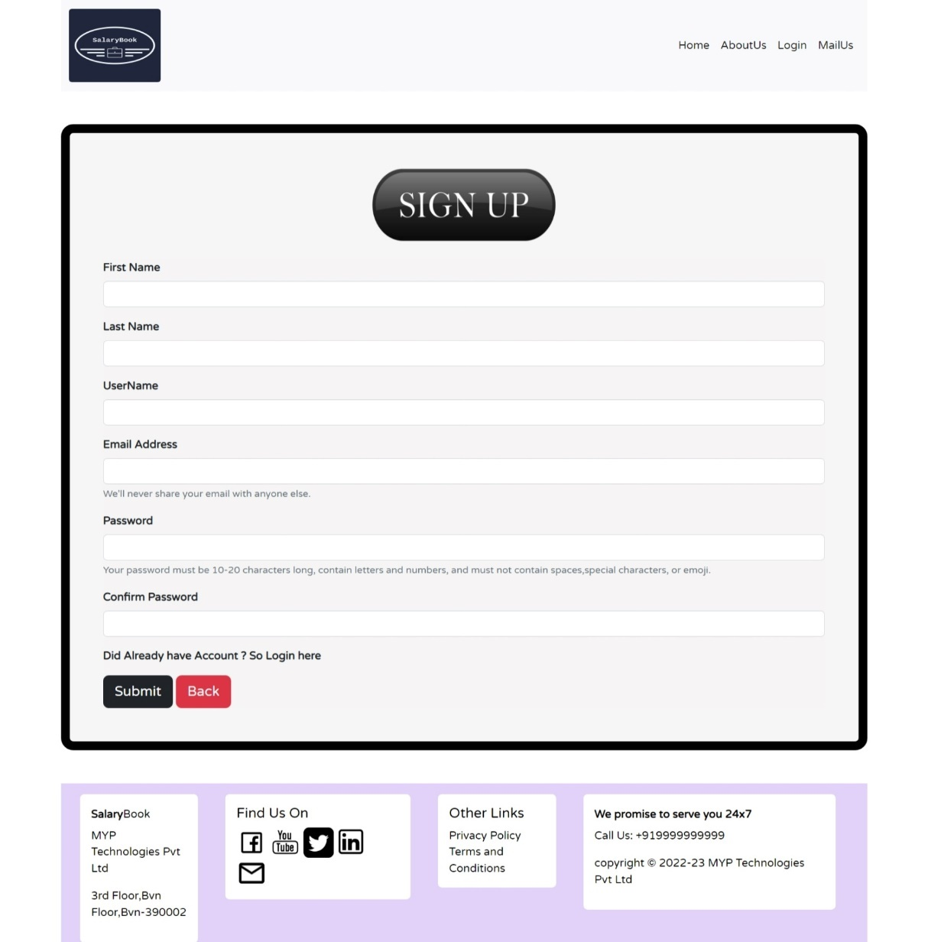

Fig 3.6 Signup Page

First User register to our web applications with field is first name ,last name, username, Email address, password and confirm password field. All fields are required . So all the fields required and fill that fields carefully. After signup page user will redirect to the login page.

### 3.1.7 Otp Verify Page

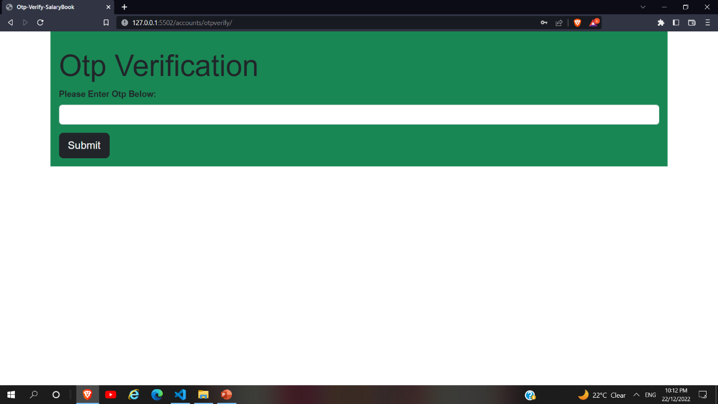

Fig 3.7 Otp Verify Page

After successfully login user will redirect to the otp verify page. User receive 8 digits otp on the their registered email id. After User add otp Success fully then user will be to redirect to the Dashboard Page.

### 3.1.8 Dashboard Page

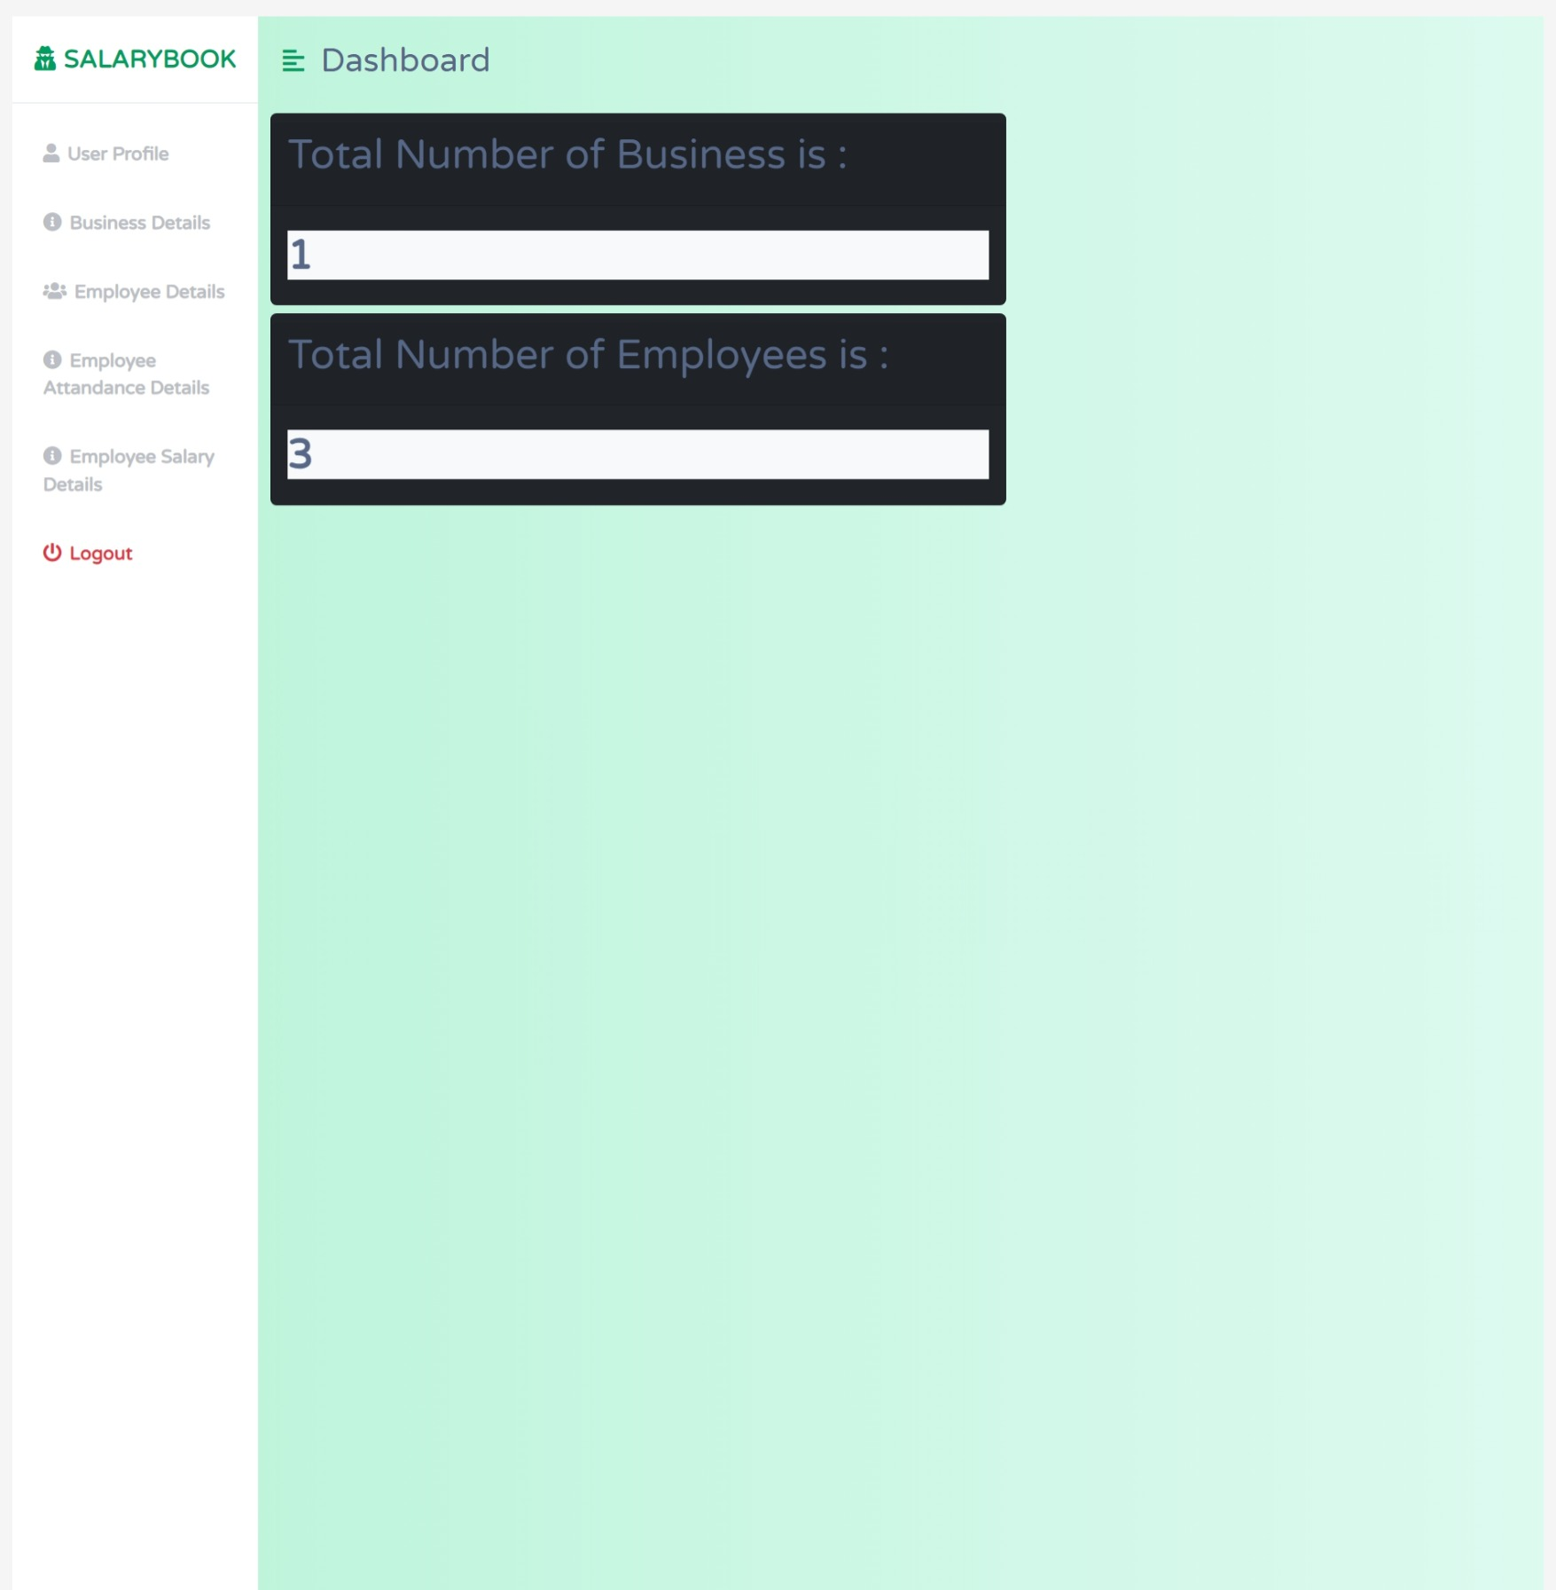

Fig 3.8 Dashboard Page

After successfully login user will redirect to the dashboard page and user is manage all the details show as above. In dashboard page user will see total number of business and total numbers of employees.

### 3.1.9 Profile Page

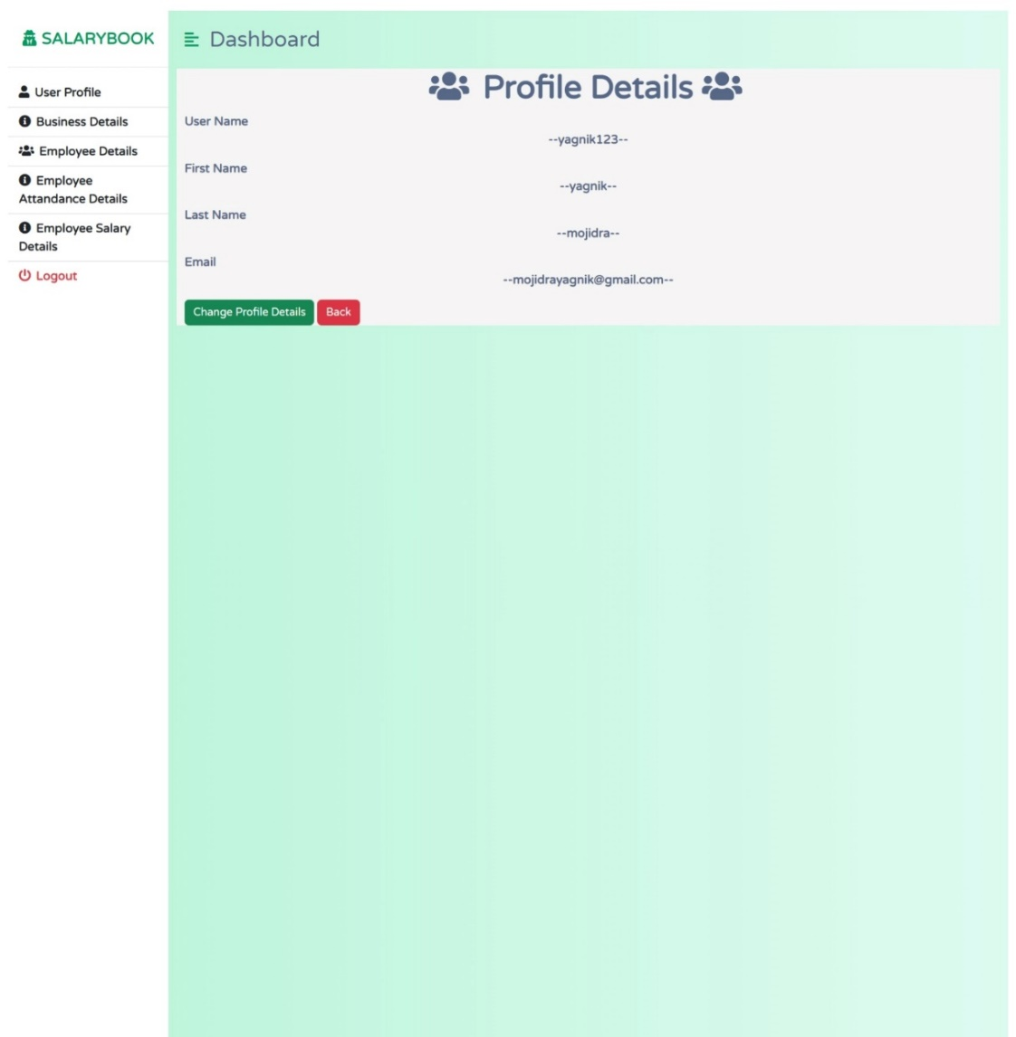

Fig 3.9 Profile Page

When user is click profile detail section user see their profile details. In this page user is change user profile using change profile details button. When user is click that button that time open the change profile form and user is able to change their profile page. That page is about of user profile .

### 3.1.10 Business Details Page

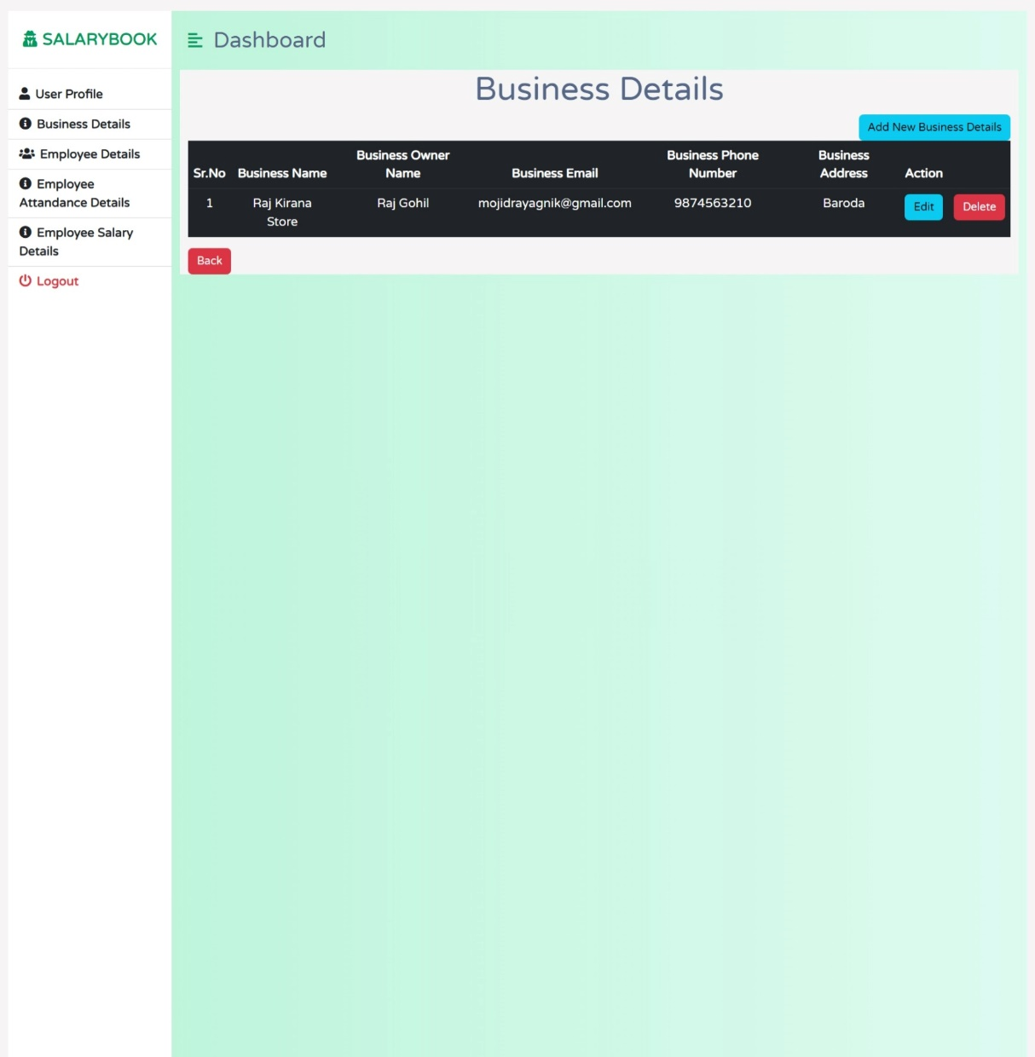

Fig 3.10 Business Details Page

That page is about to Business details page. There is option has Add new Business details, Edit and Delete Button .When User is Click on the Add new business Details Button at a time add business details page is open add user will be able to add their business details. When user is click on the edit button at a time a edit business details page is open and user is able to edit their business details. When user is click on the delete that time that records will be deleted.

### 3.1.11 Employees Details Page

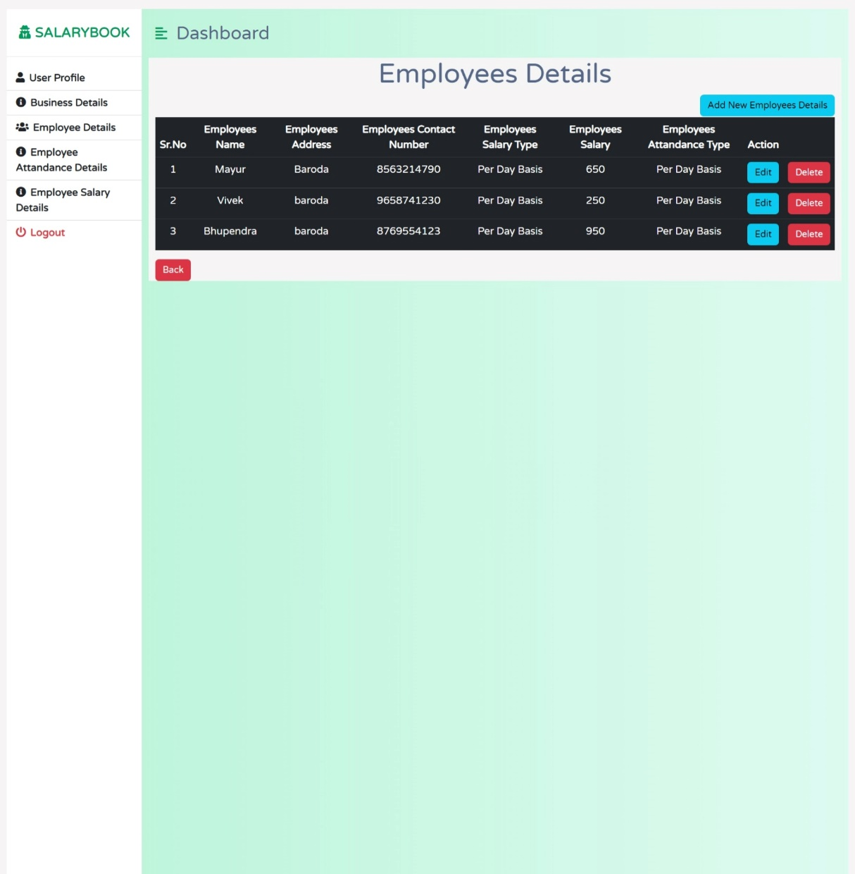

Fig 3.11 Employees Details Page

That page is about to Employees details page. There is option has Add new Employees details, Edit and Delete Button .When User is Click on the Add new Employees Details Button at a time add Employees details page is open add user will be able to add their Employees details. When user is click on the edit button at a time a edit Employees details page is open and user is able to edit their Employees details. When user is click on the delete that time that records will be deleted.

### 3.1.12 Employees Attendance Details Page

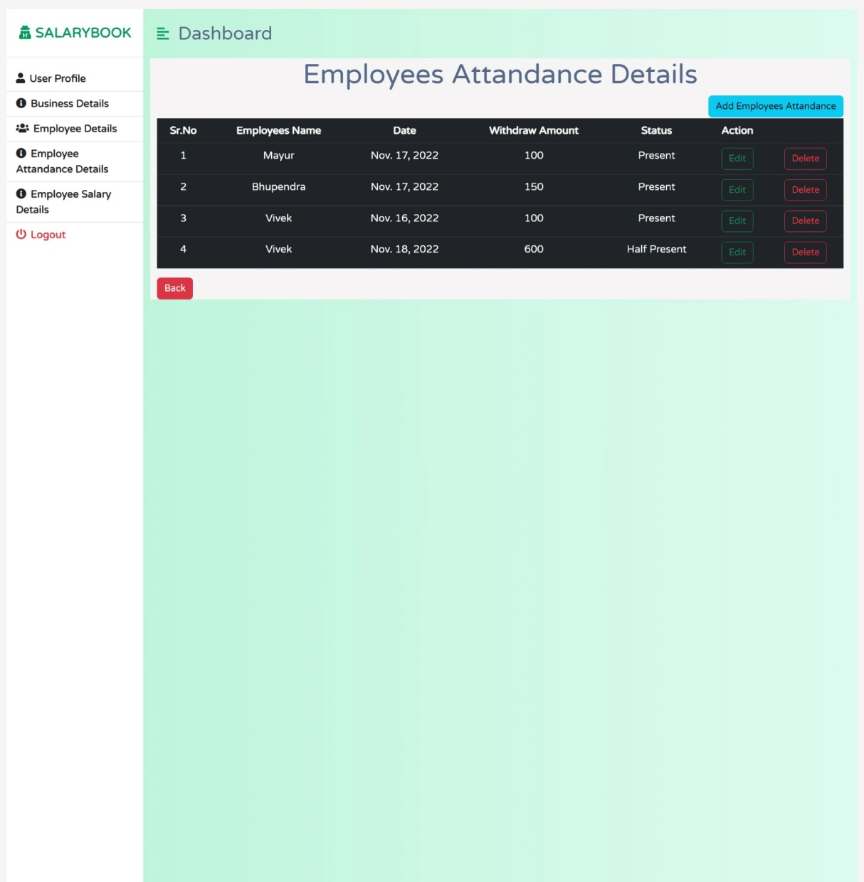

Fig 3.12 Employees Attendance Details Page

That page is about to Employees Attendance Details page. There is option has Add new Employees Attendance details, Edit and Delete Button .When User is Click on the Add new Employees Attendance Details Button at a time add Employees Attendance details page is open add user will be able to add their Employees Attendance details. When user is click on the edit button at a time a edit Employees Attendance details page is open and user is able to edit their Employees Attendance details. When user is click on the delete that time that records will be deleted.

### 3.1.13 Employees Salary Details Page

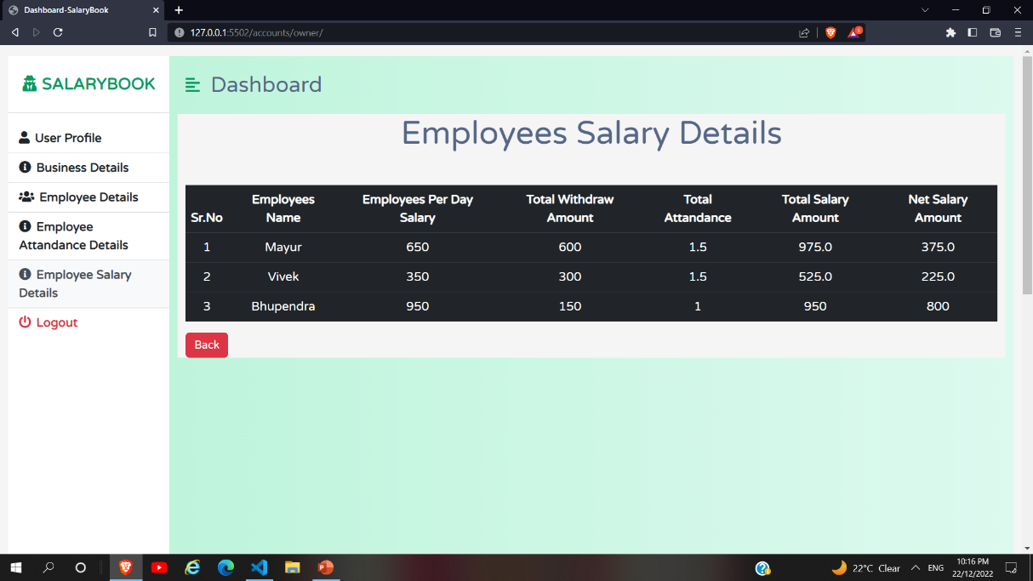

Fig 3.13 Employees Salary Details Page

That page is about to Employees Salary Details page. There is only views options then user only shows employees salary details.

## 

## 3.2 Backend

### Database MongoDB

* **MongoDB Atlas Community Version:**

The Community version of our distributed database offers a flexible document data model along with support for ad-hoc queries, secondary indexing, and real-time aggregations to provide powerful ways to access and analyze your data.

The database is also offered as a fully-managed service with [MongoDB Atlas](https://www.mongodb.com/atlas/database). Get access to advanced functionality such as auto-scaling, serverless instances (in preview), full-text search, and data distribution across regions and clouds. Deploy in minutes on AWS, Google Cloud, and/or Azure, with no downloads necessary.

* There is list we uses this type of models in the mongo DB database:

User Models 🡪 Store user info about all user information.

Business Models 🡪 Store Business info about all the business information.

Employees Models 🡪 Store Employees info about all the employees information.

Employees Attendance Models 🡪 Store Employees attendance details of all 0the employees.

* User Models:

|  |  |
| --- | --- |
| Id | By default this incremented by 1 |
| Password | Password in Encrepted |
| last_login | Date and time show |
| is_supername | Means admin access are there or not |
| Username | This is username |
| first_name | First name of user |
| last_name | Last name of the user |
| Email | Email of the user |
| is_staff | True and false |
| is_active | True and false |
| date_joined | Date and time show |

* Business Models:

|  |  |
| --- | --- |
| Id | This is id incremented by 1 |
| business_name | Name of the business |
| business_address | Name of the business address |
| business_mail | Mail of the business |
| business_owner_name | Business owner name |
| Business_mobile_number | Business mobile number |

* Employees Models:

|  |  |
| --- | --- |
| Id | This is id incremented by 1 |
| Employee_name | Employee name field |
| Employee_contact_number | Employee contact number |
| Employee_address | Employee address |
| Employee_salary | Employee Salary |
| Employee_salary_type | Employee Salary type(Per Day basis) |
| Employee_attandance_type | Employee Attandance type |

* Employees Attandance Models:

|  |  |
| --- | --- |
| Id | Id incremented by 1 |
| Employee_name | Employee name as the foreign key |
| Withdraw amount | Employee Withdraw Amount |
| Attendance_date | Date of attendance of employee |
| Date_updated | Date |
| Types | Present Absent Half Present |

### Django

* Django is a Python framework that makes it easier to create web sites using Python.
* Django takes care of the difficult stuff so that you can concentrate on building your web applications.
* Django emphasizes reusability of components, also referred to as DRY (Don't Repeat Yourself), and comes with ready-to-use features like login system, database connection and CRUD operations (Create Read Update Delete).
* For more details reference this site: <https://docs.djangoproject.com/en/4.1/ref/>

# 

# REFERENCES

1. [**https://www.mongodb.com/docs/**](https://www.mongodb.com/docs/)
2. [**https://developer.mozilla.org/en-US/docs/Web/CSS/Reference**](https://developer.mozilla.org/en-US/docs/Web/CSS/Reference)
3. [**https://developer.mozilla.org/en-US/docs/Web/HTML/Reference**](https://developer.mozilla.org/en-US/docs/Web/HTML/Reference)
4. [**https://developer.mozilla.org/en-US/docs/Web/JavaScript/Reference**](https://developer.mozilla.org/en-US/docs/Web/JavaScript/Reference)
5. [**https://getbootstrap.com/docs/4.4/getting-started/introduction/**](https://getbootstrap.com/docs/4.4/getting-started/introduction/)
6. [**https://docs.djangoproject.com/en/4.1/ref/**](https://docs.djangoproject.com/en/4.1/ref/)
7. [**https://docs.python.org/3/reference/index.html**](https://docs.python.org/3/reference/index.html)